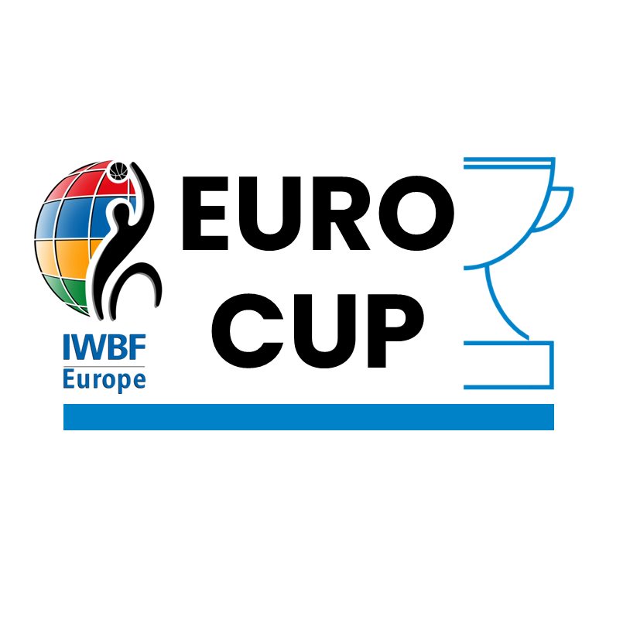

IWBF Europe

ENTRY FORM

EUROCUP 2024

Competition dates

- Champions Cup Group Stage Rounds: Thursday 1st – Sunday 4th February 2024
- **NEW** EuroCup 1 Group Stage Thursday 1st – Sunday 4th February 2024

- Champions Cup Quarter Finals Thursday 7th – Sunday 10th March 2024
- EuroCup 2 & 3 Group Stages Thursday 7th – Sunday 10th March 2024

- EuroCup 1, 2 and 3 Finals: Thursday 25th – Sunday 28th April 2024

- Champions Cup Final 4: Thursday 2nd – Sunday 5th May 2024

EuroCup Entry Form
Every Club entering EuroCup must compete this form.
If the Club would like to bid to host a round of EuroCup 2024 a separate form “BID DOCUMENT – HOST OF EUROCUP 2024” must be completed also.
This form must be completed by a person who has authority to act on behalf of the Club
Name of CLUB | Click or tap here to enter Name.
IWBF Europe Team Code  (xxx-xx) (new club put NEW-00) | Click or tap here to enter XXX-XX.
Name of Club Chairperson / President | Click or tap here to enter Name.
NAME & CONTACT OF RESPONSIBLE PERSON
Name of Club Contact Person: | Click or tap here to enter Name.
Mobile / Cell Phone Number:  (Include international dialling code) | Click or tap here to enter Phone Number.
Contact possible by: | WhatsApp | ☐ | Viber | ☐
Email Address: | Click or tap here to enter Email Address.
Club Information
Post Address of Club: | Click or tap here to enter Address.
Club Website: | Click or tap here to enter website.
Club Email: | Click or tap here to enter Email Address.
Club Facebook: | Click or tap here to enter Facebook.
Club Twitter: | Click or tap here to enter Twitter.
Club Instagram: | Click or tap here to enter Instagram.
Conditions of Entry
- The Club accepts and agrees to participate in accordance with the EuroCup Competition Regulations set out in the “Manual of Regulations for the Conduct of Wheelchair Basketball Competitions in Europe” (Version: September 2019 or later version if published)

- In the event of cancellation of any round of EuroCup in which the Club is to participate, the Club agrees to pay an equal share of any costs for accommodation, local transport, game venue hire and food provision that are incurred but cannot be recovered by the LOC.

Declaration – Authorised Person
Name of Authorised Person | Click or tap here to enter Name.
Email Address | Click or tap here to enter text Email Address.
Position in Club | Click or tap here to enter Position.

Return form to competitions@iwbf-europe.org no later than 31st July 2023

