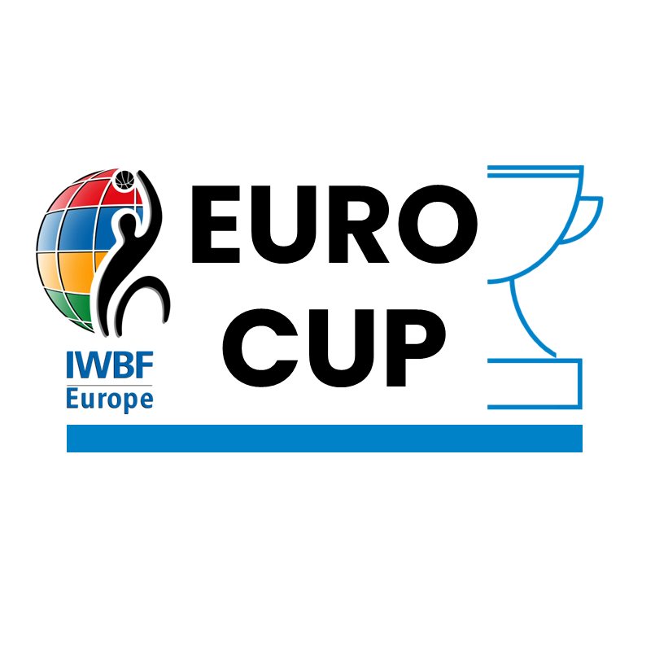

IWBF Europe

BID DOCUMENT

HOST
OF
EUROCUP 2024

EuroCup Bid Document

Any team making a bid to host an event are expected to carefully read the separate guidance document which details the obligations of an organiser of a EuroCup event.
This form must be completed by a person who has authority to act on behalf of the Host Club and Local Organising Committee.
Name of HOST CLUB | Click or tap here to enter Name.
IWBF Europe Team Code  (xxx-xx) | Click or tap here to enter XXX-XX.
Name of Club Chairperson / President | Click or tap here to enter Name.
Competition Bid
Please indicate which EuroCup Round(s) you are making a bid to host – check EuroCup Guidance Document for competition dates and qualification criteria:
Champions Cup  Group Stage | ☐ | EuroCup 1, 2 & 3  Group Stage |  |  |  | ☐
Champions Cup  Quarter Final | ☐ | EuroCup Final 1, 2 & 3 |  |  |  | ☐
Champions Cup  Final 4 | ☐ | Qualification Tournament |  |  | ☐
Location of Competition
City and Country: | Click or tap here to enter City and Country.
Local Organising Committee
Name of LOC Contact Person: | Click or tap here to enter Name.
Mobile / Cell Phone Number:  (Include international dialling code) | Click or tap here to enter Phone Number.
Contact possible by: | WhatsApp |  | ☐ | Viber | ☐
Email Address: | Click or tap here to enter Email Address.
Declaration
If the bid is successful, the Host Club and Local Organising Committee (LOC) undertakes to:

- Enter into a contract with IWBF Europe specifying obligations, terms and conditions;

- Comply with the General Regulations and Internal Regulations of IWBF Europe, the Manual of Regulations for the Conduct of Wheelchair Basketball Championships in Europe and the Rules of Play as from time to time adopted by IWBF Europe;

- Use FIBA LiveStats (minimum version 7) for all the games

- Use video server / channel provided by IWBF Europe for the Live Stream of all games;

- Accept English as the official language of the tournament;

- Maintain absolute political and religious neutrality and shall not tolerate any form of discrimination, racial or otherwise at the tournament.

IWBF Europe has the right to withdraw the right to host the event if conditions are not fulfilled. In the event that the event is withdrawn, the LOC agrees to reimburse IWBF Europe all costs that have been incurred by IWBF Europe and invited teams in preparation for the event.

Information
- IWBF Europe will only enter into a contract with a HOST CLUB when their National Organiser of Wheelchair Basketball (NOWB) is a Member of IWBF Europe.

- Where a separate contract is in place between the HOST CLUB and a company or group organising the event IWBF Europe will hold the HOST CLUB responsible for the contract.

Declaration – Authorised Person
Name of Authorised Person | Click or tap here to enter Name.
Email Address | Click or tap here to enter text Email Address.
Position in Host Club | Click or tap here to enter Position.

Please fill in next pages (Section A – F) of this form with
further information to support your bid

Further Information to Support the Bid
Section A – Arrival and Departure of Teams
1. | The name of the nearest international airport?
Click or tap here to enter text.

2. | What is the distance (km) to travel to the tournament accommodation form the airport and how many minutes in normal traffic will it take to drive from the Airport to the tournament accommodation?
Click or tap here to enter text.

3. | Will you provide transport from the airport to the tournament accommodation and back to the airport after the competition? Will there be a cost to the teams for this transport? How many wheelchairs (daily use and basketball) can fit in the transport?
Click or tap here to enter text.

Section B – Accommodation
4. | Hotel Details (for each hotel complete also separate Form A)
Hotel 1
Name: |  | Click or tap here to enter Name.
Address: |  | Click or tap here to enter Address.
Website: |  | Click or tap here to enter WWW.
Contact email: |  | Click or tap here to enter Contact email.
Staff speak English |  | Yes | ☐ | No | ☐
Type |  | Hotel | ☐ | Other (state) | Click or tap here to enter text.
Use for |  | Teams | ☐ | ITOs | ☐
Hotel 2
Name: |  | Click or tap here to enter Name.
Address: |  | Click or tap here to enter Address.
Website: |  | Click or tap here to enter WWW.
Contact email: |  | Click or tap here to enter Contact email.
Staff speak English |  | Yes | ☐ | No | ☐
Type |  | Hotel | ☐ | Other (state) | Click or tap here to enter text.
Use for |  | Teams | ☐ | ITOs | ☐
Hotel 3
Name: |  | Click or tap here to enter Name.
Address: |  | Click or tap here to enter Address.
Website: |  | Click or tap here to enter www.
Contact email: |  | Click or tap here to enter text Contact Email.
Staff speak English |  | Yes | ☐ | No | ☐
Type |  | Hotel | ☐ | Other (state) | Click or tap here to enter text.
Use for |  | Teams | ☐ | ITOs | ☐
5. | Can you arrange extra accommodation before the tournament if team pay for this?
Click or tap here to enter text.
6. | Can you arrange extra accommodation after the tournament if team pay for this?
Click or tap here to enter text.
Section C – Food & Refreshment
7. | Which meals will be provided at the accommodation and which at the sports venue?
Breakfast |  | Click or tap here to enter text.
Lunch |  | Click or tap here to enter text.
Dinner |  | Click or tap here to enter text.
8. | Is there enough space for more than one team to eat their meals at the same time as another team? If yes, how many teams can eat their meals at the same time?
Click or tap here to enter text.
9. | Are meals to be provided elsewhere other than the accommodation and sports venue, if yes provide details?
Click or tap here to enter text.
10. | How far in advance (how many days) do you need to know about any religious, ethnic or allergy requirement for meals?
Click or tap here to enter text.
11. | Do you intend to offer packed lunch to teams instead of a hot meal lunch?
Click or tap here to enter text.
12. | Can drinks / light snacks be purchased at any time?
Accommodation |  |  | ☐ Yes | ☐ No | Sports venue | ☐Yes | ☐ No
13. | Is there a café / small shop near to the sports venue for teams to buy drinks or food, if so, how long to push to the place (distance and time)?
Click or tap here to enter text.

Section D – Transport
14. | What kind of transport will be provided for transport between accommodation and sports venue, and is the transport accessible to wheelchair users?
Click or tap here to enter text.
15. | What is the distance (km) to travel from the tournament accommodation to the sports venue and how many minutes in normal traffic will it take to drive?
Click or tap here to enter text.
16. | Can each team travel as one separate group?
Click or tap here to enter text.
17. | Will transport be available throughout the day between the accommodation and the sports venues?
Click or tap here to enter text.
18. | Will transport be available to take officials (technical delegate, referees, classifiers and other IWBF Europe representatives / Officials) between accommodation and sports hall/s?
Click or tap here to enter text.
19. | What kind of transport is available to IWBF officials and is the transport accessible to wheelchair users?
Click or tap here to enter text.

Section E – Playing Facilities and Programme
20. | Playing Venue Details
Venue 1 (main venue)
Name: |  | Click or tap here to enter Name.
Address: |  | Click or tap here to enter Address.
Website: |  | Click or tap here to enter WWW.
Contact email: |  | Click or tap here to enter Contact email.
Playing Surface: |  | Wooden | ☐ | Plastic | ☐ | Other (state) | Click or tap here to enter text.
Number of courts: |  | Choose Number.
Venue 2 (if necessary)
Name: |  | Click or tap here to enter Name.
Address: |  | Click or tap here to enter Address.
Website: |  | Click or tap here to WWW.
Contact email: |  | Click or tap here to Contact email.
Playing Surface: |  | Wooden | ☐ | Plastic | ☐ | Other (state) | Click or tap here to enter text.
Number of courts: |  | Choose a Number.
21. | Does every sports venue have all the technical equipment required by IWBF – Visual Score / Electronic Clock / 24 Second Display / Foul Markers / Possession Arrow?
Click or tap here to enter text.

22. | Do you have enough qualified or competent table officials (4 per game) who regularly officiate? If no, will you train people to adequate standard for this job?
Click or tap here to enter text.

23. | Do you have enough staff / volunteers who can work with “FIBA LiveStats”? If no, will you train people to adequate standard for this job?
Click or tap here to enter text.

24. | Are all facilities in the sports venue accessible to wheelchairs including changing rooms and toilets?
Click or tap here to enter text.

25. | Does each team have a changing room for its own?
Click or tap here to enter text.

26. | Is there a separate changing room only for the referees?
Click or tap here to enter text.

27. | Is there a separate changing room for female players and also female referees if required?
Click or tap here to enter text.

28. | Is there a room available for the Tournament Technical Committee of IWBF Europe at the Sports Venue?
Click or tap here to enter text.

29. | Will WIFI be organised in the sports hall for use by IWBF Europe Technical Delegates and ITOs?
Click or tap here to enter text.

Section F – Documents & Extra Contact
30. | Please enclose the following documents to complete your bid:
- A map showing the host town / city in relation to the country and capital city

- A map showing the accommodation site, sports venues and other important facilities in relation to each other in the host town / city

- A ground plan of the sports venue(s) and photograph of the playing court;

- Photographs and details of the dimensions of a standard bedroom and bathroom at the hotel(s).

31. | Provide the contact details of a person in your organising committee who speaks English and can be contacted about information and decisions: (if the Chairperson / LOC Contact Person does not speak English)
Name: |  | Click or tap here to enter Name.
Mobile / Cell Phone Number:  (Include international dialling code) |  | Click or tap here to enter Phone Number.
Contact possible by: |  | WhatsApp | ☐ | Viber | ☐
Email Address: |  | Click or tap here to enter Email Address.

